

Dr. Maria, Harris inc.
2021-12-24
Dr. Harris
71331 Morgan Corners, Bookerberg, OH 13639
Phone: 2367531302
Fax: 7113939278

Re: Cassandra, Santos
PHN: 4899707530
Birthdate: 23-Sep-1949
Address: 6564 Silva Lakes Apt. 010, West Christine, WI 15559
Patient number: 5809588367

To Whom It May Concern:

This is a medical letter to state the above patient is pregnant with expected delivery date of 27-Jul-2025. Hoping this information is satisfactory for your requirements.

Thank you.

Sincerely,
Dr. Maria, Harris
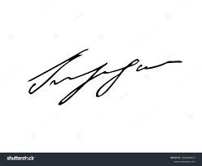
FRCS© NCMP
Clinical Assistant Professor, UBC
Department of Obstetrics and Gynecology SMH

